2-

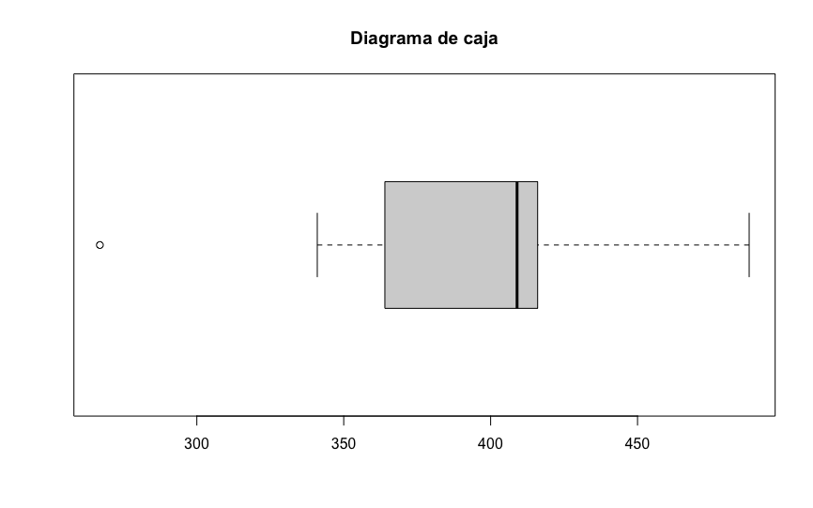

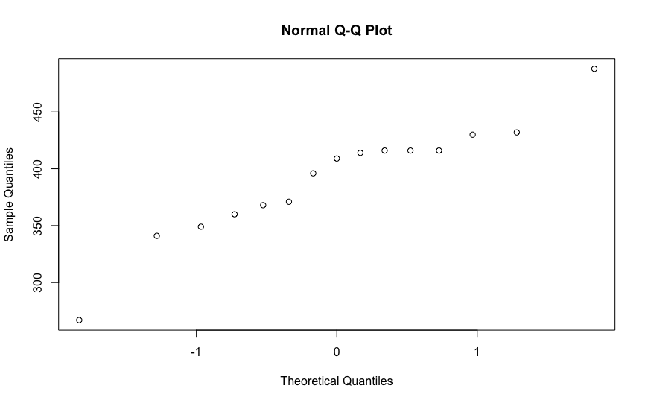

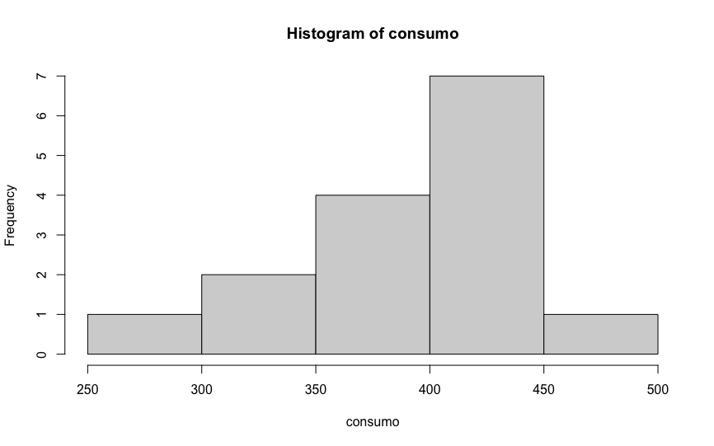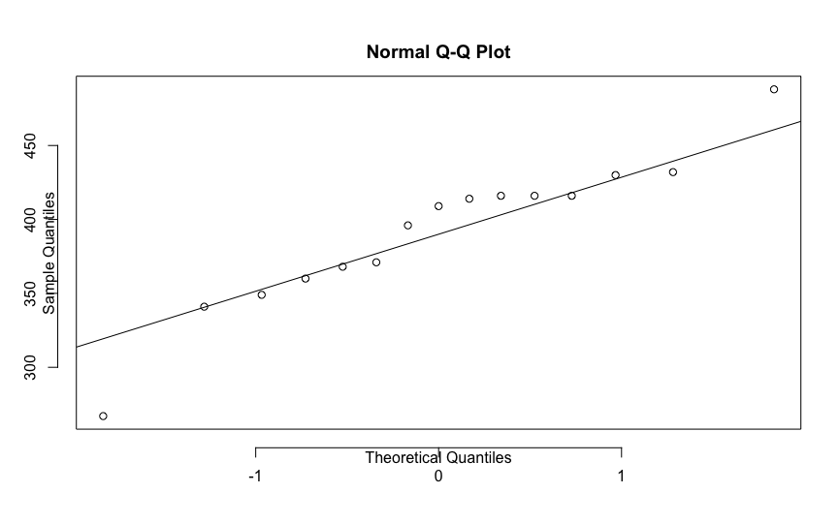

4.-

|  |  |  |  |  |  |
| --- | --- | --- | --- | --- | --- |
|  | Muestra 1 | Muestra 2 | Muestra 3 | Muestra 4 | Muestra 5 |
| Media (𝑥̅) | 374.5 | 383.4231 | 368.8846 | 379.2692 | 368.0385 |
| Desviación típica (𝑠) | 58.19227 | 59.94609 | 41.3863 | 56.8011 | 52.11179 |